Spark Declarative Pipeline (DLT)
Requirements, Prerequisites & Client Questionnaire

Project: ServiceNow → ADF → ADLS → Spark Declarative Pipeline (Advanced DLT)
Document type: Requirement gathering / prerequisite specification
Status: Draft for client review
Owner: Data Engineering

Contents

1. Purpose
This document defines everything we need to build a production-grade declarative pipeline on Databricks (Spark Declarative Pipelines / DLT) that ingest from an ADLS landing zone and lands curated data across a medallion architecture. It captures what is already decided on our side, prerequisites that must be in place before development, the complete list of questions to close out with the client, and the design decisions that depend on those answers — especially SCD/CDC, mandatory metadata, per-table properties, and logging/audit.
Once every open item here is answered, the pipeline can be built without further requirement rounds.

2. Solution Overview & Flow
Our scope begins at the ADLS landing zone — we do not own extraction. ADF copies source data to ADLS; the Spark Declarative Pipeline consumes it via Auto Loader into Bronze, applies CDC/SCD into Silver, and builds business models in Gold.
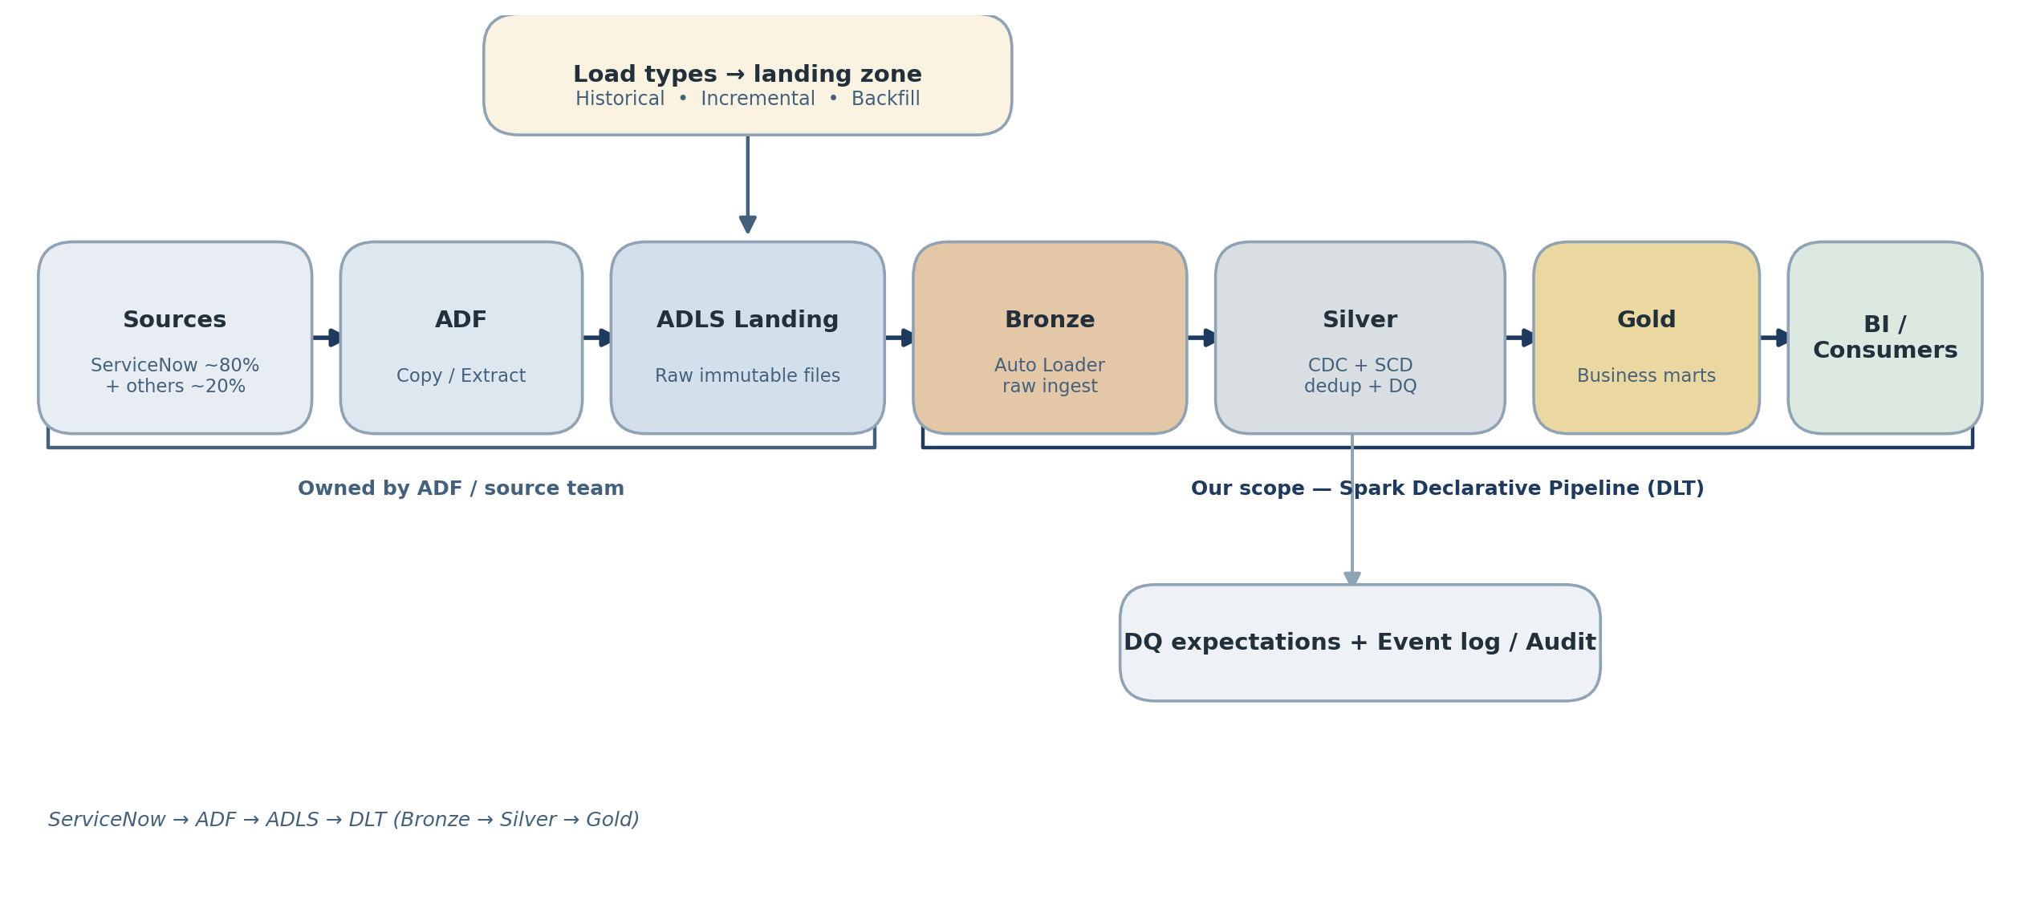
Figure 1 — End-to-end flow. ADF/source team owns extract → landing; we own Bronze → Silver → Gold.
Scenarios in scope: historical (initial) load, incremental load, and future backfill. Sources are ~80% ServiceNow, ~20% to be confirmed.

3. Prerequisites (before build starts)
3.1 Source (ServiceNow) — owned by ADF/source team
- List of in-scope tables + expected go-live order.
- Confirmation that sys_id is the record identifier, and sys_updated_on is available as the change timestamp on every in-scope table.
- How deletes are surfaced (see Section 5.4).

4. Client Questionnaire (Requirement Gathering)
Grouped by theme. Each item is a blocker unless marked optional.
4.1 Keys & CDC (drives merge logic)
Q1. Confirm the primary/business key per table. Default assumption: sys_id. Any tables with composite keys?
Q2. Confirm the sequencing column used to order changes. Fallback if a table lacks it?
Q3. Can the same record appear multiple times within a single landed batch (multiple updates)? Determines de-dup on latest sequence value before applying.
Q4. Can events arrive out of order across batches? DLT SEQUENCE BY handles this, but we must size the state window.
4.2 SCD Requirements (per table)
Q5. For each in-scope table, which history behavior is required — SCD Type 1 (keep latest only, upsert/overwrite, no history) or SCD Type 2 (full history with effective-from/effective-to and current flag)?
Q6. For SCD2 tables: which columns should trigger a new history version (TRACK HISTORY ON list, or track-all-except a noise list such as eg - sys_mod_count)?
Q7. For SCD2: is point-in-time / as-of querying an actual requirement, or is history retained only for audit?
Q8. Retention: how long must history / soft-deleted records be kept? Any purge policy?
4.3 Load Scenarios
Q9. Are ALL in-scope tables delivered incrementally, or are some delivered as full snapshots (periodic full extracts)? This directly changes the SCD application approach — incremental/CDC tables use a streaming table with APPLY CHANGES (SEQUENCE BY the change timestamp), whereas full-snapshot tables use snapshot-based CDC (APPLY CHANGES FROM SNAPSHOT) where the engine derives inserts/updates/deletes by comparing consecutive snapshots. Please classify each table as INCREMENTAL or SNAPSHOT.
Q11. Incremental: how frequently does ADF land new data (hourly / daily / continuous)? Freshness SLA the business expects?
Q12. Backfill: what triggers it (late corrections, source re-extract, bug fix)? Is it a window (date range) or a full re-extract?
Q13. During backfill, should corrected records create new SCD2 versions or restate existing versions in place? Materially different logic.

4.4 Data Quality Rules (DLT Expectations)
Q14. Mandatory / non-nullable columns per table.
Q15. Business validity rules (valid value domains, date sanity, referential expectations).
Q16. On a bad record, desired action: keep & flag, drop, or fail the pipeline (maps to expect / expect_or_drop / expect_or_fail).
Q17. Do rejected records need to be quarantined to a separate table for review?
4.5 Architecture, Targets & Table Properties
Q18. Confirm Bronze/Silver/Gold layering and the target catalog.schema naming per layer.
Q19. What table properties are required per table? We need direction on: (a) partitioning and/or liquid clustering / clustering keys and the columns to cluster on; (b) whether Change Data Feed (delta.enableChangeDataFeed) must be enabled for downstream consumers; (c) auto-optimize / optimized-write and target file size; (d) VACUUM / deleted-file retention (delta.deletedFileRetentionDuration) and log retention windows; (e) table comments, owner, and governance tags/classifications (e.g. PII, cost-centre) to apply as Unity Catalog tags or TBLPROPERTIES. Provide defaults plus any per-table overrides.
4.6 Deletes
Q20. Does ServiceNow surface hard deletes to us? A normal sys_updated_on incremental pull will NOT capture deleted rows — deletions typically require the audit-delete stream (sys_audit_delete) or a periodic full-key reconciliation. Which approach is provided?
Q21. Should deletes be soft (flag _is_deleted, retain row) or hard (physically remove)? For SCD2, deletes normally close the current version rather than remove it — confirm.
4.7 Security & Compliance
Q22. Which tables/columns contain PII (incident notes, user records, contact info)? Masking or tokenization required?
Q23. Encryption, row/column-level security, or Unity Catalog access constraints?
Q24. Data residency / regulatory constraints (GDPR right-to-erasure interaction with SCD2 history)?
4.8 Operations
Q25. What orchestrates the pipeline — triggered on ADF completion, scheduled, or continuous? Who owns the trigger?
Q26. Alerting expectations on failure / SLA breach / data-quality threshold (email, Teams, PagerDuty)?
Q27. Reconciliation: does the business require source-vs-target row-count reporting?
Q28. Environments (dev/test/prod) and promotion process.

5. SCD & CDC Design Requirements
5.1 Keys are mandatory — checkpoints do NOT replace them
A common misconception is that streaming checkpoints remove the need for primary keys. They do not — the two solve unrelated problems:
- Checkpoints (Structured Streaming / Auto Loader) track stream progress — which files/offsets have been consumed. They provide exactly-once processing and fault recovery. They have no notion of record identity.
- Keys tell the CDC engine which incoming row corresponds to which existing target row, so it can upsert (SCD1) or open/close a version (SCD2).
Conclusion: every table processed with APPLY CHANGES / AUTO CDC must declare its key(s). For ServiceNow this is sys_id, present on standard, custom, and m2m tables — so the key is effectively pre-solved and only needs confirmation.
5.2 What the CDC engine needs per table
Input | ServiceNow default | Notes
KEYS (record identity) | sys_id | Mandatory. Composite keys allowed.
SEQUENCE BY (ordering) | sys_updated_on | Mandatory. Resolves out-of-order & duplicate events; keeps latest per key.
SCD type | Per table (Q5) | Type 1 (upsert) or Type 2 (history).
TRACK HISTORY ON/EXCEPT | Per table (Q6) | Type 2 only — which columns spawn a new version.
Delete handling | Per Q20/Q21 | APPLY AS DELETE WHEN <condition> closes/removes records.
Load style | Per Q9 | Incremental → APPLY CHANGES; full snapshot → APPLY CHANGES FROM SNAPSHOT.
5.3 SCD Type 2 output columns
For SCD2 tables, DLT auto-generates history-tracking columns (effective-start / effective-end). A derived is_current flag is added for consumer convenience; current state is queried with WHERE is_current = true.
5.4 Delete strategy
Incremental pulls keyed on sys_updated_on silently miss deletions. Confirm one of:
- Client provides a delete feed (e.g. sys_audit_delete) → mapped to APPLY AS DELETE.
- Periodic full-key snapshot for reconciliation to detect disappeared keys (aligns with snapshot-based CDC, Q9).
- Deletes are out of scope and records retained indefinitely (client sign-off required).

6. Historical / Incremental / Backfill Handling
Scenario | Approach | Client input
Historical (initial) | One-time full extract landed to ADLS; Bronze ingests all files; Silver builds initial SCD state. | Volumes, date cut-off (Q10)
Incremental | Auto Loader picks up only new files (checkpoint-tracked); SEQUENCE BY applies latest changes. Source-side watermark (sys_updated_on) owned by ADF. | Cadence, SLA (Q11)
Snapshot | For full-snapshot tables, APPLY CHANGES FROM SNAPSHOT derives changes by comparing consecutive snapshots (incl. deletes). | Which tables are snapshot (Q9)
Backfill | Preferred: land corrected records into the stream and let SEQUENCE BY re-apply (non-destructive). Alternative: full refresh, which reprocesses ALL landed data — requires full file retention. | Trigger, window vs full, restate vs new-version (Q12/Q13)
Backfill caution: a streaming-table full refresh reprocesses from scratch, so every raw file it ever consumed must still exist in ADLS. Confirm the landing-zone retention policy supports this; otherwise backfill must use the non-destructive path.

7. Mandatory Metadata Columns (every table)
Every Bronze+ table carries a consistent audit/lineage envelope — non-negotiable for production traceability, debugging, and reconciliation.
7.1 Mandatory
Column | Purpose | Source
_source_system | Origin system (e.g. servicenow) | Constant / config
_source_table | Original source table name | Config / path
_ingested_at | When ADF landed the file to ADLS | ADF or _metadata
_processed_at | When DLT processed the record | current_timestamp()
_load_type | historical / incremental / backfill / snapshot | Config / path
_batch_id / _pipeline_run_id | Correlates a record to a pipeline run | Pipeline runtime
Business key | Record identity | sys_id
Change timestamp | CDC sequencing | sys_updated_on
7.2 Strongly recommended
Column | Purpose
_source_file_name / _source_file_path | Trace a row to its landed file (_metadata.file_path)
_record_hash | Hash of business columns for change detection / SCD2 gating
_is_deleted | Soft-delete flag (if soft deletes chosen)
_ingestion_date | Partition / pruning column
SCD2 tables additionally carry the DLT-managed effective-start / effective-end columns plus derived is_current.

8. Logging & Audit Strategy
Logging is required, but most of it is built in. There are three distinct layers — do not conflate them.
8.1 DLT Event Log (built-in — use first)
DLT automatically emits an event log capturing pipeline runs, data-quality/expectation results, row counts (flow progress), lineage, and performance/backpressure. It can be published to a queryable table via pipeline settings — giving most operational observability with zero custom code. Use it for run history, expectation pass/fail, records dropped, lineage, latency, and failure diagnostics.
8.2 Custom Control / Watermark table (if needed)
Auto Loader checkpoints already track file progress, so a control table is mainly needed to coordinate load type and backfill windows and to mirror the source-side watermark owned by ADF. Would contain: source_table, last_processed_load_date, last_source_watermark (sys_updated_on), active_load_type, backfill_from / backfill_to, updated_at.
8.3 Custom Audit / Reconciliation table (recommended for prod)
A business-facing run summary for reconciliation and SLA reporting — cleaner than parsing the raw event log for non-engineers.
Column | Purpose
pipeline_run_id / batch_id | Run correlation
source_table / target_table | Scope of the run
load_type | historical / incremental / backfill / snapshot
records_read / records_written | Volume
records_inserted / updated / deleted | CDC breakdown
records_quarantined / rejected | Data-quality outcome
run_start / run_end / duration | SLA tracking
status | success / failed / partial
error_summary | Failure diagnostics
source_row_count vs target_row_count | Reconciliation delta
Decision to confirm (Q27): is 8.3 a business deliverable, or is the built-in event log (8.1) sufficient?

9. Open Decisions Log
# | Decision | Depends on | Owner | Status
1 | SCD type per table | Q5 | Client | Open
2 | Incremental vs snapshot classification per table | Q9 | Client | Open
3 | SCD2 change-tracking columns | Q6 | Client | Open
4 | Delete handling mechanism | Q20/Q21 | Client/ADF | Open
5 | Backfill pattern + landing retention | Q12/Q13 | Client/ADF | Open
6 | Data-quality action per rule | Q14-Q17 | Client | Open
7 | Per-table Delta properties (clustering, CDF, retention, tags) | Q19 | Client | Open
8 | Custom audit table required? | Q27 | Client | Open
9 | Landing zone format & folder convention | — | ADF team | Open
10 | PII columns & masking | Q22 | Client | Open

10. Assumptions (flag if wrong)
- Extraction (source → ADLS) is owned by the ADF team; our scope begins at the landing zone.
- sys_id is the record key and sys_updated_on the change timestamp on all in-scope ServiceNow tables.
- Landed files are immutable once written (required for Auto Loader).
- Medallion (Bronze/Silver/Gold) is the target architecture on Unity Catalog.

